
Lecture – The Omniscience of God
The miraculous powers of the human brain

September 16, 2021
Recovery Europe Bible fellowship

Contents
Lecture – The Omniscience of God 2
The miraculous powers of the human brain 2
Pre-Introduction 2
Introduction 3
Main Parts of the Brain and their Functions 4
The Neuron 5
The Architecture of the Neuron 5
Humans produce new brain cells throughout their lives 6
The hippocampus 6
Neurogenesis - Adult brain can repair and regenerate after damage 7
Neuroplasticity – What is it? 8
Neuroplasticity vs. Neurogenesis 8
Methods that enhance neuroplasticity 9
Effects of speaking in tongues on the brain 10
Conclusion 11

Lecture – The Omniscience of God

The miraculous powers of the human brain
2 Timothy 1:10
But is now made manifest by the appearing of our Saviour Jesus Christ, who hath abolished death, and hath brought life and immortality to light through the gospel.
The gospel brings to light the life and power and immortality of God that only God used to have. Immortality is exclusive to God. God lives in Himself and immortality is something that God had before death came into existence. We have the nature of God. We are Godkind not mankind.
I am complete in Him (Colossians 2:10). I have something inside of me that is bigger than creation. I am a custodian of the divine nature of God.

Pre-Introduction
For academic purposes, Science is generally grouped into Natural or Life Sciences, Physical Sciences, Social Sciences (Humanities) and Political Sciences. All these disciplines of science are touched one way or the other by the proceeding research findings of the brain, but the Life Sciences is where we will focus in this lecture. What Medical Science has succeeded in doing is to expose the truth that is already revealed in the word of God and the intrinsic characteristics of creation. It also exposes the limitations of human abilities.
An example of the intricate wonders of the human physiology is the cascade of events that take place in a minor cut on the finger that starts to bleed. Behind the bleeding is a cascade of actions and reactions taking place for you not to bleed to death. First the smooth muscles in the blood vessels constrict and this might reduce blood loss almost instantaneously.
In another step, blood components that encounter an injured blood vessel will group together and form a platelet plug, through a chain reaction of blood clotting chemicals known as clotting factors. This process also creates a protein called fibrin, which is stronger than the platelet plug. The mesh-like structures of fibrin form the actual clot.
Anti-clotting factors in the blood balance the clotting factors to ensure that the clot does not become too large. As the injury heals, the blood clot is broken down, and it is absorbed by the body. The tough fibrin is dissolved by an enzyme known as plasmin.
There are people who cannot produce these blood clotting factors due to defects in the chromosome. These are referred to as hemophiliacs and the disease condition is known as hemophilia. Through the help of medical science, there is medical therapy available for such conditions.
Likewise, some people are predisposed to forming blood clots easily or it could be as a result of other factors like taking oral contraceptives, age-related arteriosclerosis. Legs that remain still for too long, allowing blood to pool, also are at risk for forming blood clots. This latter condition is known as deep venous thrombosis. People who are taking extended airline flights and don’t have sufficient room to stretch their legs should take care to move about the plane frequently.
Blood clot formation is very dangerous because it can migrate to the lungs, heart or brain leading to stroke or heart attack. There are also medicines called blood thinners that prevent such clot formations.

Introduction
The brain is believed to be the most complex organ in the human body. It makes up about 2 percent of a human’s body weight, which in an average adult is about 1.4 kg. It is about 60 % fat and the remaining 40% is a combination of water, protein, carbohydrates and salts.
The brain serves many functions. Through the five senses of sight, smell, hearing, touch and taste, the brain receives messages, often many at the same time.
The brain controls thoughts, memory, speech, emotion, touch, arm and leg movements, vision, temperature, hunger and the function of many organs within the body. It also determines how people respond to stressful situations e.g., writing of an exam, loss of a job, illness etc., by regulating heart and breathing rates.
The brain is an organized structure, divided into many components that serve specific and important functions.

Main Parts of the Brain and their Functions
The brain can be divided into the cerebrum, brainstem and cerebellum.
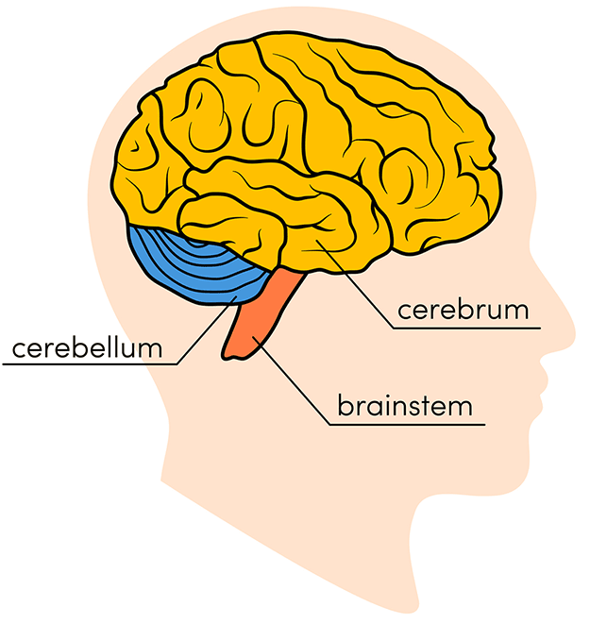Ref: xxx
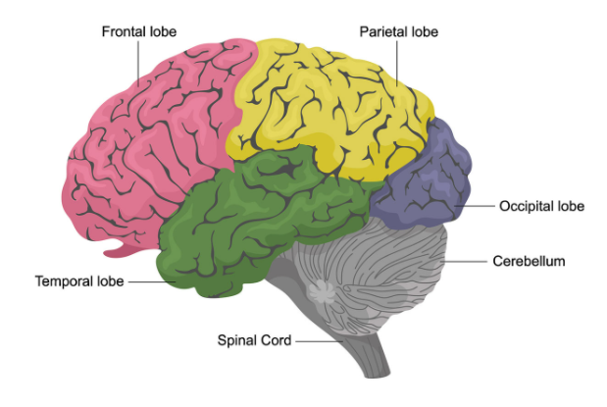
The cerebrum is the front of the brain and makes up 85 percent of the brain’s weight. The darker outer portion is referred to as the gray matter while the lighter inner section underneath is called the white matter with billions of nerve fibers (axons and dendrites).
The cerebrum initiates and coordinates movement and regulates temperature. Other areas of the cerebrum enable speech, judgment, thinking and reasoning, problem-solving, emotions and learning. Other functions relate to vision, hearing, touch and other senses.
Each brain hemisphere (parts of the cerebrum) has four sections, called lobes: frontal, parietal, temporal and occipital. Each lobe controls specific functions.
The brain is made up of two types of cells: neurons and glial cells. The neuron is responsible for sending and receiving nerve impulses or signals. Glial cells provide among other things, support and nutrition, maintain equilibrium and facilitate signal transmission in the nervous system. For the purpose of this lecture, we will focus on the neurons.

The Neuron
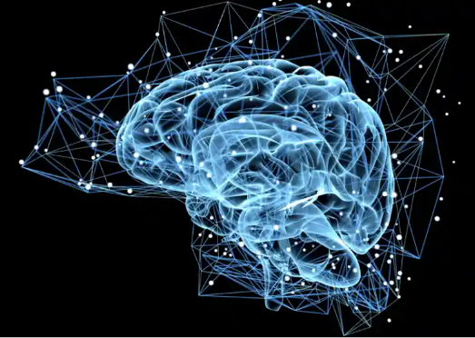
The neuron is the basic working unit of the brain, a specialized cell designed to transmit information to other nerve cells, muscle, or gland cells.
Neurons are required for learning and memory processes. Everything we think and feel and do would be impossible without the work of neurons and their support cells.
The brain contains 90 billion neurons. They are information messengers. They use electrical impulses and chemical signals to transmit information between different areas of the brain, and between the brain and the rest of the nervous system. Your brain can generate enough electricity to power some light bulbs, according to some experts.

The Architecture of the Neuron

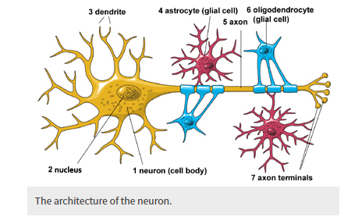Ref: xxx
Neurons have three basic parts: a cell body, an axon (5) and a dendrite (3). Within the cell body is a nucleus (2), which controls the cell’s activities and contains the cell’s genetic material.
The axon looks like a long tail and transmits messages from the cell. Dendrites look like the branches of a tree and receive messages for the cell. Neurons communicate with each other by sending chemicals, called neurotransmitters, across a tiny space, called a synapse, between the axons and dendrites of adjacent neurons.
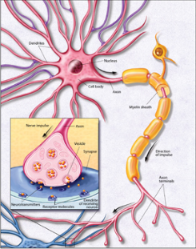
When neurons receive or send messages, they transmit electrical impulses along their axons, which can range in length from a tiny fraction of an inch (or centimeter) to three feet (about one meter) or more. Each neuron has a certain role to play in a particular place in the brain.

Humans produce new brain cells throughout their lives
It was previously thought that humans stopped producing neurons in their late teens. However, studies have shown that humans continue to produce new neurons in a part of the brain involved in learning, memory and emotion throughout adulthood.
Many new neurons are produced in the hippocampus in babies, but it has been a matter of hot debate whether this continues into adulthood – and if so, whether this rate drops with age as seen in mice and nonhuman primates.
Studies now reveal that new brain cells are continually produced in the hippocampus and subventricular zone, replenishing these brain regions throughout a lifetime.

The hippocampus
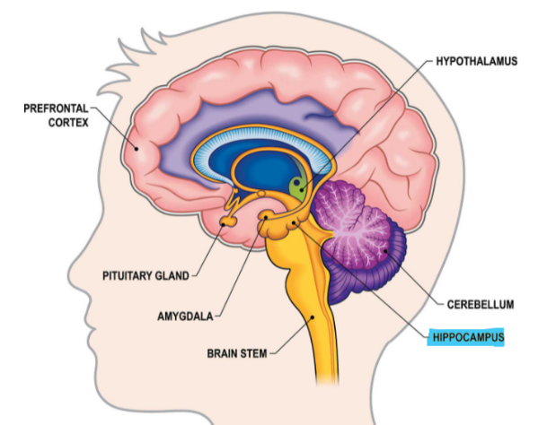
The hippocampus is part of the deeper structures of the brain alongside the Pituitary gland, Hypothalamus, Amygdala, Pineal gland etc.
A curved seahorse-shaped organ on the underside of each temporal lobe, the hippocampus is part of a larger structure called the hippocampal formation. It supports memory, learning, navigation and perception of space.
It receives information from the cerebral cortex and may play a role in Alzheimer’s disease.
Scientist revealed that in the hippocampus, there are these pluripotent stem cells that are a pool of cells that don’t normally do anything, they are quiescent, and then they can undergo division. Those daughter cells are the ones that exponentially divide and make many more cells and differentiate towards becoming a neuron.
Levels of the mother cells dropped with age but the cells they give rise to did not drop. Thousands of new, immature neurons were found at the time of death regardless of age, concluding that humans can still make enough neurons even with fewer left of these mother cells.
It seems that in this respect, humans are different from mice – where [neuron production] goes down with age really fast – and this could mean that we need these neurons for our complex learning abilities and cognitive behavioral responses to emotions.
The findings could help in developing treatments for neurological conditions such as dementia. It is now important to look at what happens in the brains of those with Alzheimer’s and emotional problems, since if there are differences in the formation of new cells in the hippocampus it could offer scientists new targets for treatment.

Neurogenesis - Adult brain can repair and regenerate after damage
Repairing damage to the brain and spinal cord poses a great challenge to medical science. Before it was thought that the adult brain is static, terminally differentiated, fully established and immutable.
In April 2020, researchers at University of California San Diego School of Medicine published new findings that shows that when adult brain cells are injured, they revert to an embryonic state.
Using the incredible tools of modern neuroscience, they were able for the first time to identify how the entire set of genes in an adult brain cell resets itself in order to regenerate. This gives us fundamental insight into how, at a transcriptional level, regeneration happens.
Earlier work by other scientists found that new brain cells are continually produced in the hippocampus and subventricular zone, replenishing these brain regions throughout life.
This work radicalizes this concept. The brain's ability to repair or replace itself is not limited to just two areas. Instead, when an adult brain cell of the cortex is injured, it reverts (at a transcriptional level) to an embryonic cortical neuron. And in this reverted, far less mature state, it can now regrow axons if it is provided an environment to grow into.

Neuroplasticity – What is it?
Neuroplasticity is surely one of the most extraordinary discoveries of the twentieth century. Our brains are truly amazing. There are stories of people who experienced an amazing, unexpected recovery after a traumatic brain injury, stroke, or other brain damage. Scientists have been working hard studying exactly these cases over the last several decades and have found the explanation behind the unlikely events is what is called neuroplasticity.
Neuroplasticity refers to the brain’s ability to adapt. “It refers to the physiological changes in the brain that happen as the result of our interactions with our environment. From the time the brain begins to develop in utero until the day we die, the connections among the cells in our brains reorganize in response to our changing needs. This dynamic process allows us to learn from and adapt to different experiences”.
Different pathways form and fall dormant, are created and are discarded, according to our experiences.
The idea implies that the brain can change its own structure and function through thought and activity is, I believe, the most important. Things like love, grief, relationships, learning, addictions, culture, technology and psychotherapies change our brains. Which means that the architecture of the brain differs from one person to the next and that it changes the course of our individual lives.
That is why the God says in the Bible book of Philippians 4:8 Finally, brethren, whatsoever things are true, whatsoever things are honest, whatsoever things are just, whatsoever things are pure, whatsoever things are lovely, whatsoever things are of good report; if there be any virtue, and if there be any praise, think on these things.

Neuroplasticity vs. Neurogenesis
Although related, neuroplasticity and neurogenesis are two different concepts.
Neuroplasticity is the ability of the brain to form new connections and pathways and change how its circuits are wired; neurogenesis is the even more amazing ability of the brain to grow new neurons
When we learn something new, we create new connections between our neurons. We rewire our brains to adapt to new circumstances. This happens on a daily basis, but it’s also something that we can encourage and stimulate.
In his book The Brain that changes itself, the Canadian Psychotherapist Norman Doidge says that:
“In the course of my travels I met a scientist who enabled people who had been blind since birth to begin to see, another who enabled the deaf to hear; I spoke with people who had had strokes decades before and had been declared incurable, who were helped to recover with neuroplastic treatments; I met people whose learning disorders were cured and whose IQs were raised; I saw evidence that it is possible for eighty-year-olds to sharpen their memories to function the way they did when they were fifty-five. I saw people rewire their brains with their thoughts, to cure previously incurable obsessions and traumas. I spoke with Nobel laureates who were hotly debating how we must rethink our model of the brain now that we know it is ever changing”.
Remember Proverbs 23: 7 For as he thinketh in his heart, so is he.

Methods that enhance neuroplasticity
- Meditation: increases spatial coordination
- Intermittent fasting: increases synaptic adaptation, promotes neuron growth, improve overall cognitive function, and decreases the risk of neurodegenerative disease
- Traveling: exposes your brain to novel stimuli and new environments, opening up new pathways and activity in the brain
- Using memory training devices: memory training can enhance connectivity in the prefrontal parietal network and prevent some age-related memory loss
- Learning a musical instrument: may increase connectivity between brain regions and help form new neural networks
- Non-dominant hand exercises: can form new neural pathways and strengthen the connectivity between neurons
- Reading: increases and enhances connectivity in the brain
- Expanding your vocabular: activates the visual and auditory processes as well as memory processing
- Creating artwork: enhances the connectivity of the brain at rest (the “default mode network” or DMN), which can boost introspection, memory, empathy, attention, and focus
- Dancing: reduces the risk of Alzheimer’s and increases neural connectivity
- Sleeping: encourages learning retention through the growth of the dendritic spines that act as connections between neurons and help transfer information across cells (Nguyen, 2016).

Effects of speaking in tongues on the brain
In 2008, the University of Pennsylvania released findings from a medical study proving that the practice of speaking in tongues is sourced by the Holy Spirit. In the study, participants’ brain activity was monitored while they spoke in tongues, giving the medical researchers scientific insight into the parts of the brain active while speaking in these “heavenly tongues”—and the results were astounding.
While trying to discover the relationship between faith and science, his study quickly ascertained that speaking in tongues is absolutely not regular language that would normally activate the frontal lobe.
The Scientist asked the question? How does this very powerful force in human history of religion and spirituality affect our brain, what’s changing or turning on or turning off in our brain during those extremely deep and powerful moments of faith.
And remarkably he discovered that what’s happening to [the test subjects when they pray in tongues] neurologically looks a lot like what they say is happening to them spiritually.
When test subjects prayed in their native language, their brain activity indicated normal behavior for speech in the frontal lobe. However, when the same test subjects prayed in tongues their brain activity showed something extremely different. The test subject’s scan showed that the frontal lobe, the part of the brain that controls language, was active when he prayed in English. But for the most part, it fell quiet when he prayed in tongues.”
Dr. Newberg confirmed this finding saying, “When they are actually engaged in this whole very intense spiritual practice for them, their frontal lobes tend to go down in activity, which is very consistent with the kind of experience that they have because they say that they are not in charge—it’s the voice of God, the Spirit of God that’s moving through them”.
Speaking in Tongues can also boost your immune system. A few years ago, a brain surgeon did a study of what happens in the brain when people pray in tongues. He found that they secreted two chemicals that can boost the immune system by 35-40%! Think about the effects this can have on opportunistic diseases such as cancer.
God created the immune system to be our defense against harmful invaders: bacterial, viral, fungal, parasitic, and even malignant. It is when the immune system is weakened that such pathogens can attack and overwhelm our bodies. We all know that keeping our immune system strong is vital to warding off diseases.
We already know that when a person speaks in tongues, he edifies himself; that is, he builds himself up, strengthens himself in his inner man (1 Cor.14:4). Now we know that we can also fortify our immune system by speaking in tongues.

Conclusion
We were not programmed to die. The Bible record of people who lived for hundreds of years is true. Sin and death brought pollution that compromised God’s original plan for man to dominate and multiply on earth.
Nevertheless, there is a hope of glory coming. A vision of glory. In Rev 20:14 And death and hell were cast into the lake of fire. This is the second death.

Injured adult neurons regress to an embryonic transcriptional growth state. Nature, 2020; DOI: 10.1038/s41586-020-2200-5

